**Joe’s Drive**

**SHADOW Control schema**

**BB8 Assembly version MK3**

Table of Contents

Main Chassis: Square motor mount 3

Needed Parts 3

Main Chassis: Motor Carriage 4

Needed Parts 4

Main Chassis: Side 2 Side Belt Pulley (MK3) 9

Needed Parts 9

Mk3 Head gimble Assembly: Head gimble Belt Pulley 12

Needed Parts 13

Servo Mount Connections 15

When installing the horns 15

Flywheel MK3 Assembly 16

# Main Chassis: Square motor mount

## Needed Parts

* 4 x 12mm Bearings

<https://www.ebay.com/itm/10-6001ZZ-12x28x8-Shielded-12mm-28mm-8mm-6001Z-Deep-Groove-Radial-Ball-Bearings-/360392098378?hash=item53e90b024a:m:m6tGabnoU6wdMFlhcOjQZpQ>

* 4 x 8mm Bearings

<https://www.ebay.com/itm/Pack-of-10-Bearing-608ZZ-8x22-mm-608Z-Metric-Ball-Bearing-VXB-Sale-Lot-Wholesale-/400073187613?hash=item5d2638611d:m:mgY3Tje8TUIMghpOEnOYl3A>

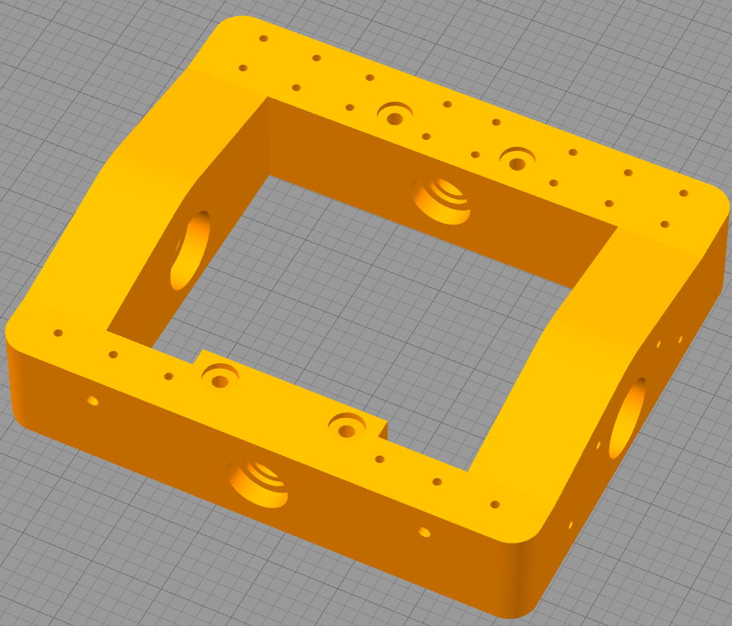

STL: Main Square.stl

# Main Chassis: Motor Carriage

## Needed Parts

* 4 x m5 x 70mm Bolts
* 4 x m5 x 25mm bolts
* 4 x m5 x nuts (non locking)
* 4 x m5 locking nuts
* 2 x m5 washers

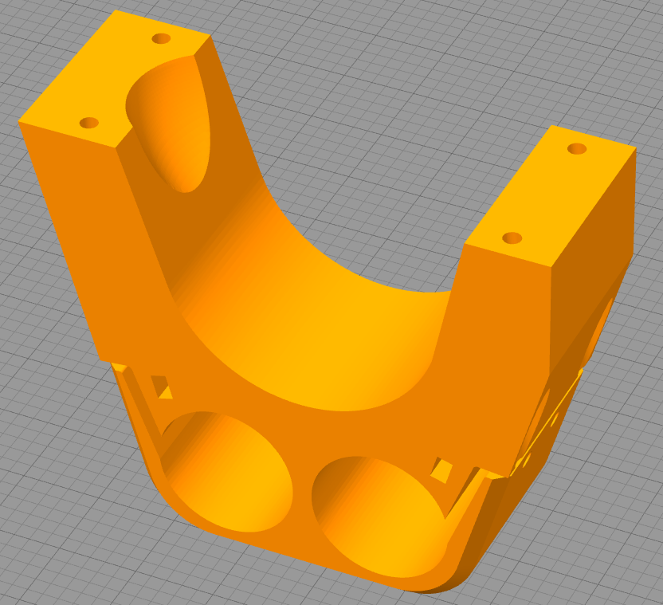

STL: Motor Carriage V3.stl

Begin by inserting a nut into each of the 2 slots per side.

Place a washer on each of the M5X25MM bolts, then insert one into each of the holes/nuts.

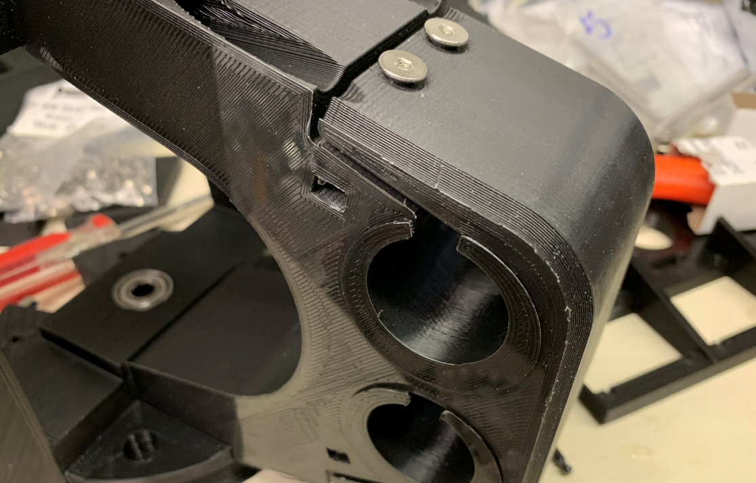

With a washer on each of the M5x70mm bolts, insert them as shown:

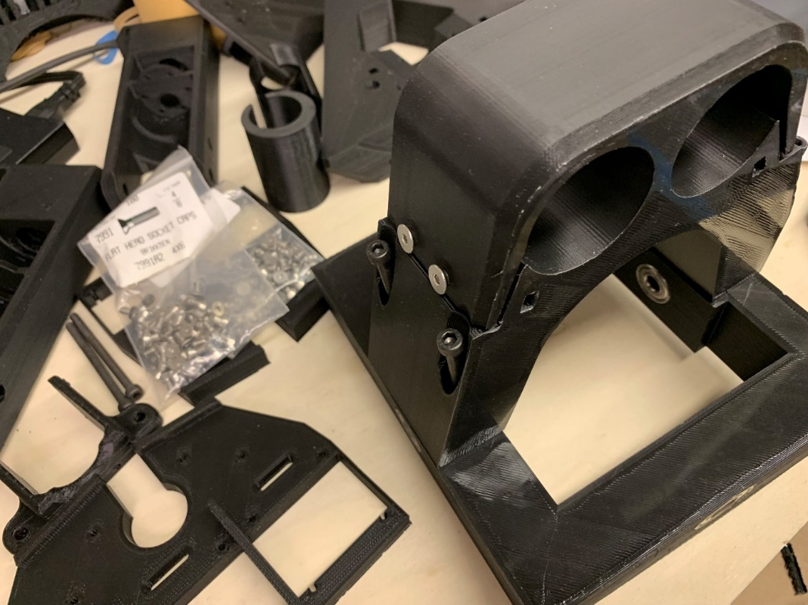

When connecting the main motor carriage to the square carriage, make sure that you attach the side that has the flat edge to the side that has the added square insert as seen below:

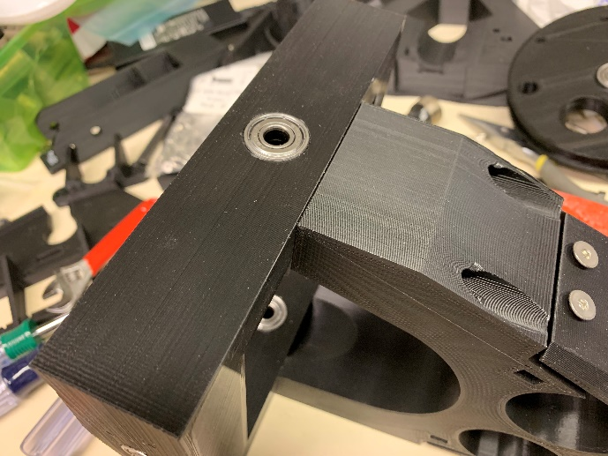 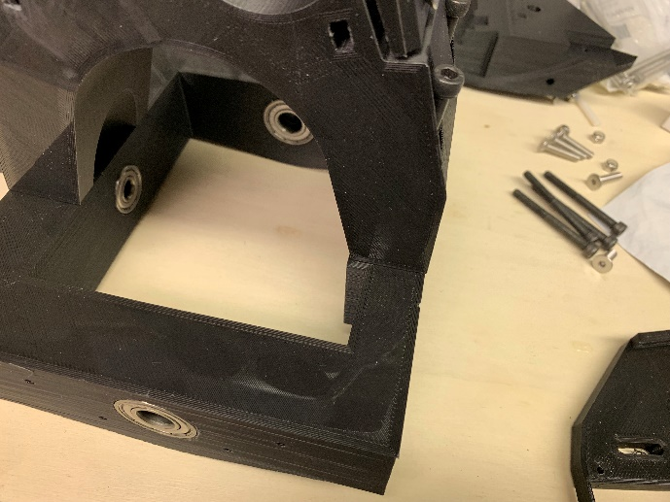

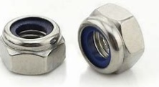**Use locking m5 nuts** to securely hold the motor carriage to the main square assembly.

Insert the 2 x 165 RPM Planetary Motors into their slots allowing for some exposure beyond the first motor ring like below.

Use their motor mounts to fit snug into their respective holes.

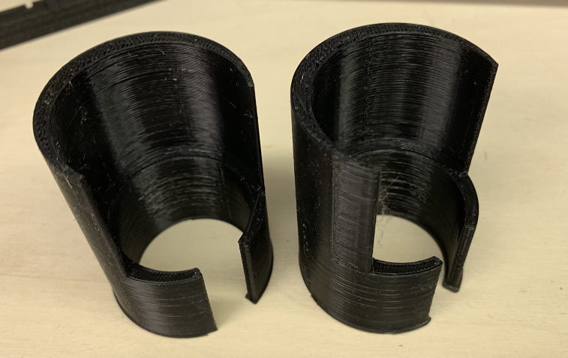

NOTE: The motors are exposed out the side where the Side to Side pulley is on the left. See next section on assembly of Side to Side Pulley (MK3).

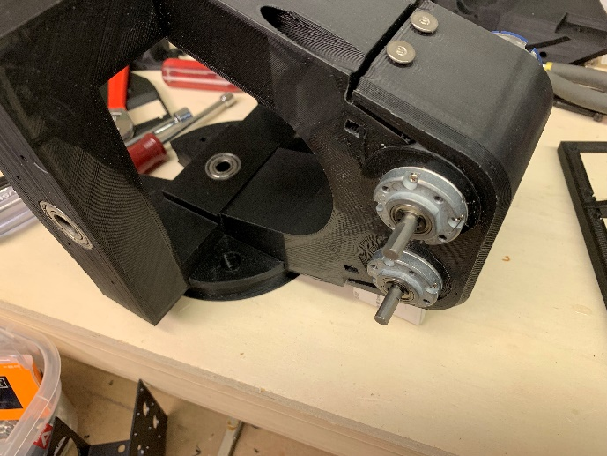 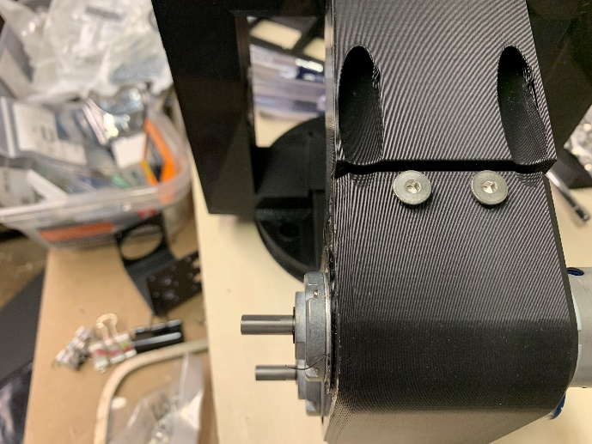

# Main Chassis: Drive Pulley (main drive)

## Needed Parts

* 8 x M3 x 12mm flat head hex screws

<https://www.amazon.com/iExcell-Assortment-Socket-Screws-Finish/dp/B01N228LCJ/ref=sr_1_fkmrnull_1?keywords=iexcell+%236-32&qid=1556420636&s=gateway&sr=8-1-fkmrnull>

or

<https://www.amazon.com/Hilitchi-260-Piece-Metric-Countersunk-Assortment/dp/B06Y3TY2FB/ref=sr_1_21?keywords=hilitchi+m3&qid=1556419617&s=gateway&sr=8-21>

* 1 x m5 nut

Affix a 12mm bore hub on to each of the pattern adapters using 4x #6 x 3/8” or M3 x 12mm machine screws. NOTE: Every other outermost hole is threaded, make sure these are in the same direction:

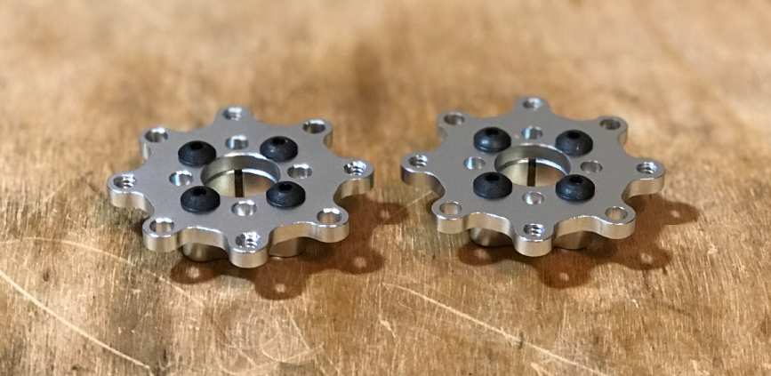

The Hub adapter lock screw will need to be aligned with a hole that is threaded. This way the screw head from the other side does not conflict with gaining access to the lock nut.

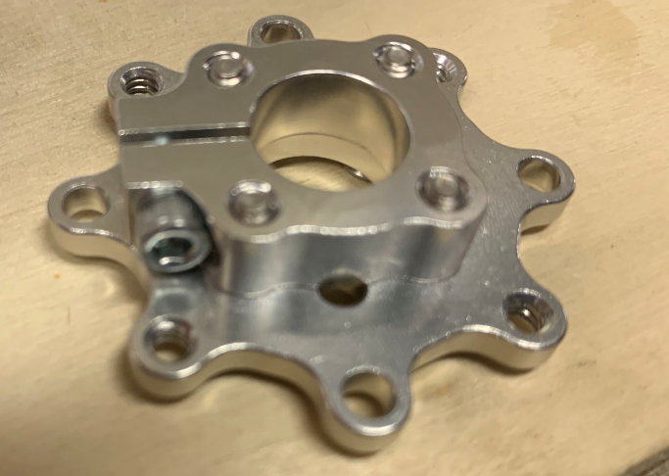 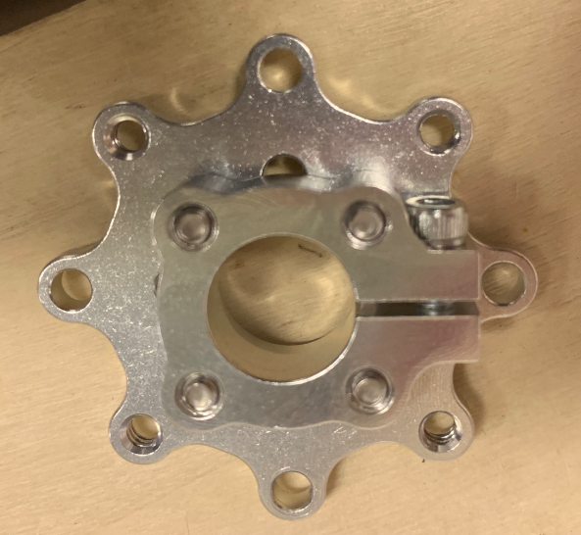

Important to get this alignment right as once you have the unit in the chassis, very hard to remove again or painful to disassemble.

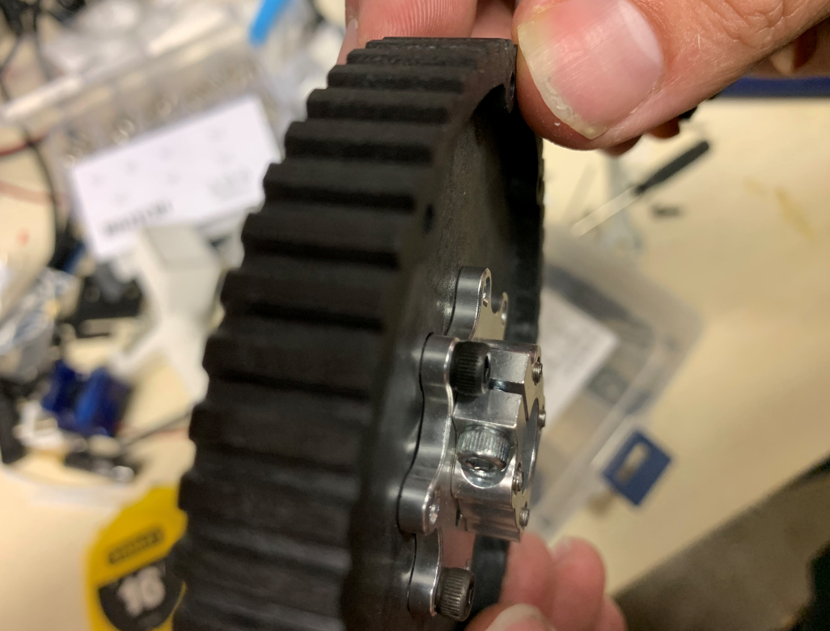 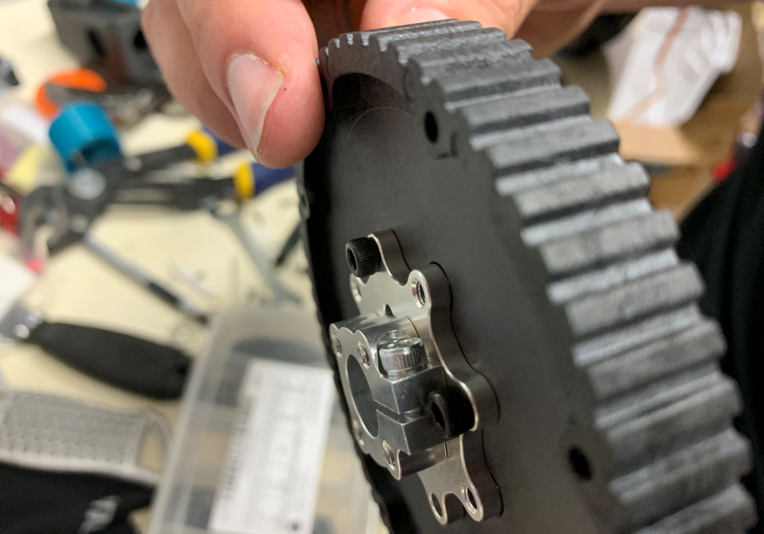

Place a hub adapter assembly on either side of the pulley. Using 8x **#6 x 3/8”** or 8x **m3 x 16mm** machine screws affix both adapters to the pulley.

NOTE: The screw will go through a smooth hole of one adapter, through the pulley, and thread in to the adjacent adapter.

See the orientation below:

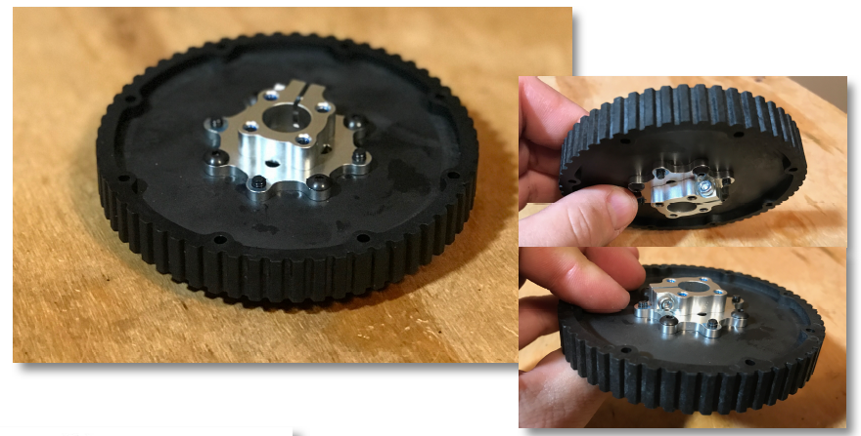

Pro Tip: The fit will be better if you shave off the edge on

the innermost hole of the pulley.

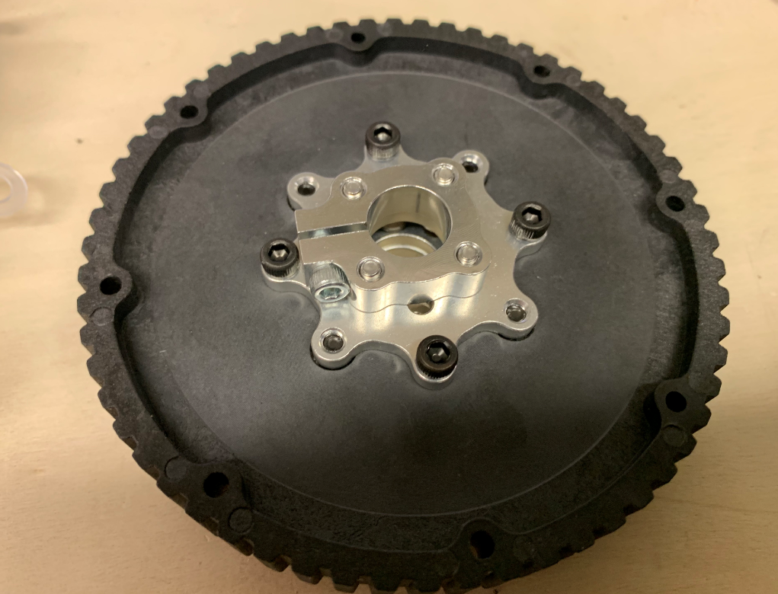

Completed part – note the alignment of the lock nuts to the screws boring through the smooth holes and into the opposite side threaded holes.

# Main Chassis: Side 2 Side Belt Pulley (MK3)

## Needed Parts

* 1 x 8mm Bearings

<https://www.ebay.com/itm/Pack-of-10-Bearing-608ZZ-8x22-mm-608Z-Metric-Ball-Bearing-VXB-Sale-Lot-Wholesale-/400073187613?hash=item5d2638611d:m:mgY3Tje8TUIMghpOEnOYl3A>

* 1 x m5 nut

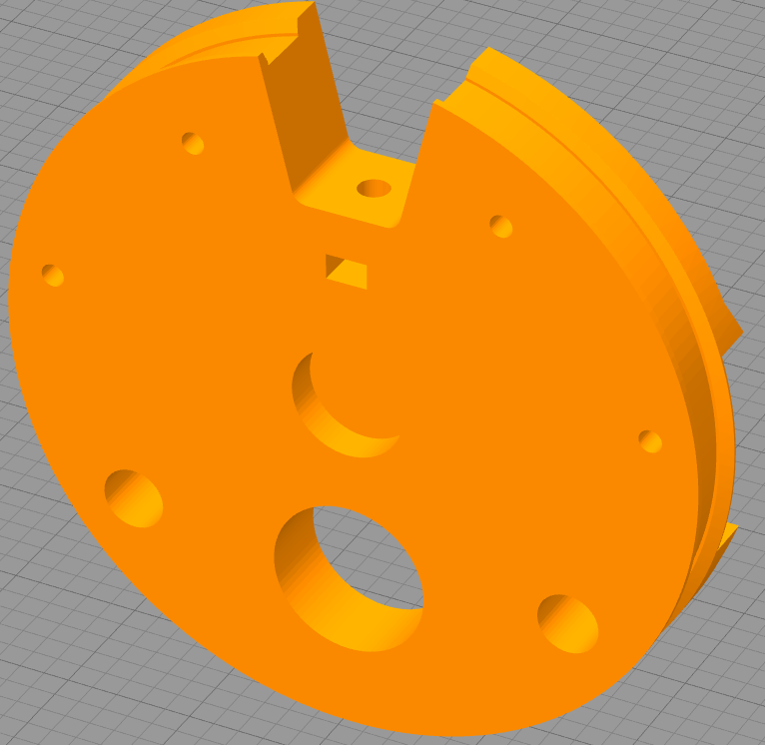

STL: S2S Pulley V4.stl

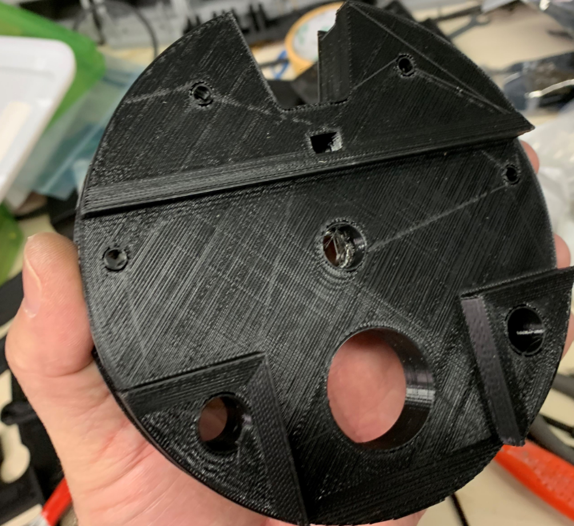

Another view of the pulley printed.. notice the main difference between MK3 and MK1-2 is the reduction of holes and placement of screw holes for the installation of the MK3 head gimble servos.

Place the pulley on the side with the flat extended side of the Motor Carriage, it may or may not fit snuggly onto the part. The 8mm bearing should be facing outward.

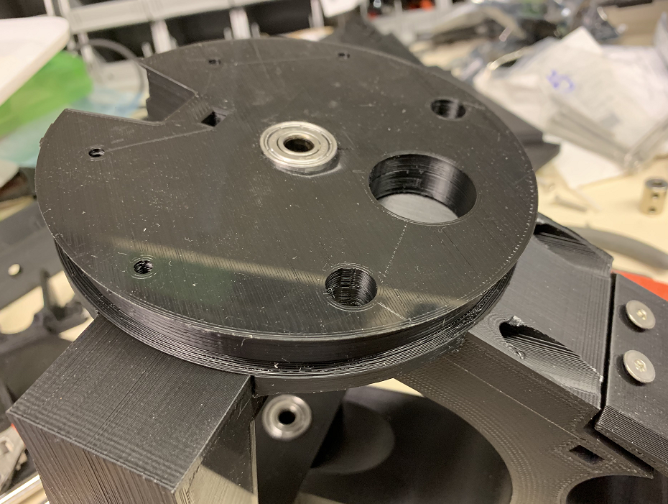

Insert the motor inserts into their respective slots…

Take note of the position of the Side to Side pulley, the motors should be facing out while the pulley is on the leftside of the motor mount. See below:

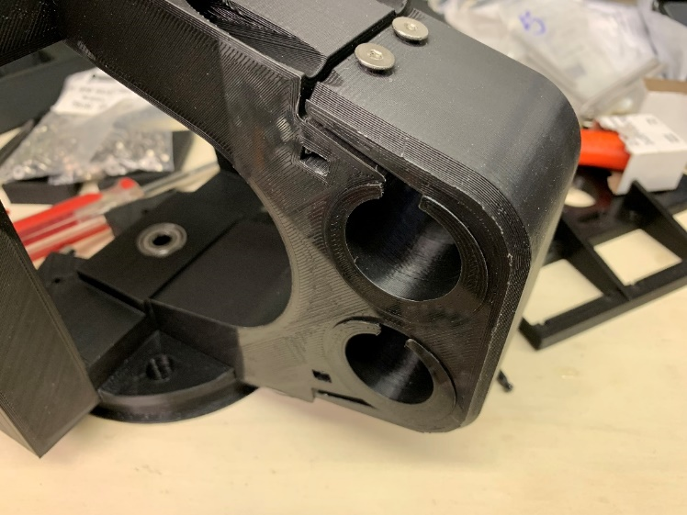

# Mk3 Head gimble Assembly: Head gimble Belt Pulley

The head assembly has changed quite a bit between the various versions. Finally replacing the whole rotation around the 12mm axle (forward/backward only) to a complete rotation capability mimicking what James Bruton created for his Version 2 and 3 versions of BB8 builds.

MK1-2 Version

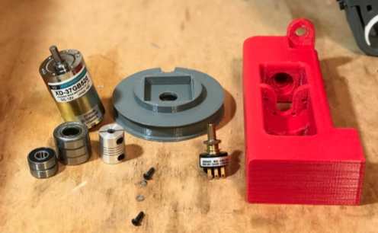 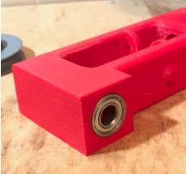

MK3 Version

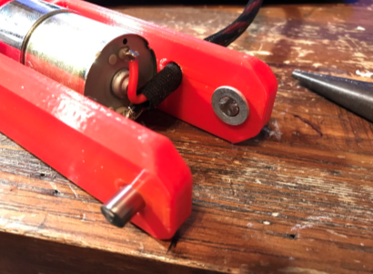 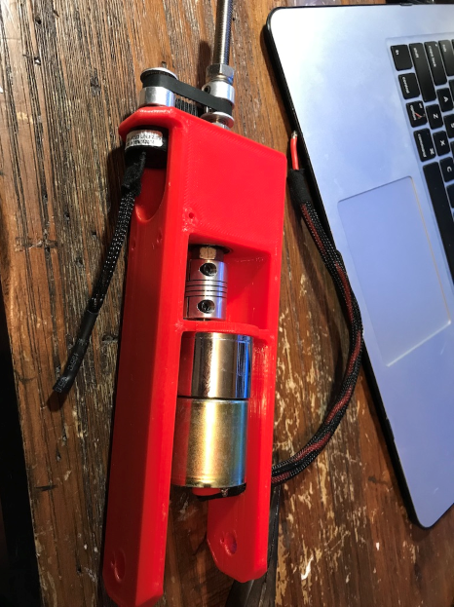

## Needed Parts

* 1 x 6mm to 8mm flex coupler  
  <https://www.amazon.com/dp/B06X9W3TNS/ref=cm_sw_r_cp_dp_T2_e0NFzbWXZ8V4V>
* 1 x Infinite Spin POT (very important)  
  <https://www.digikey.com/product-detail/en/bourns-inc/6630S0D-C28-A103/6630S0D-C28-A103-ND/3828854>
* 1 x 12v 100RPM Motor (Gear reduction ratio: 50:1)

<https://www.robotshop.com/en/12v-100rpm-583-oz-in-brushed-dc-motor.html>

* 2 x 8mm Bearings

<https://www.ebay.com/itm/Pack-of-10-Bearing-608ZZ-8x22-mm-608Z-Metric-Ball-Bearing-VXB-Sale-Lot-Wholesale-/400073187613?hash=item5d2638611d:m:mgY3Tje8TUIMghpOEnOYl3A>

* 8mm threaded rod cut to 5-1/2” Inches length (139.7mm)
* 1X 8mm nut (for lower portion of threaded rod)
* 1x 8mm lock nut (for upper portion of threaded rod)
* 2x 6mm wide and 8mm bore 20T pulleys   
  <https://www.ebay.com/itm/10PCS-2GT-GT2-Aluminum-Alloy-Timing-Pulley-for-3D-Printer-6mm-Width-Belt-Tool/182822312026?hash=item2a910f185a:m:mpnj6mWvNuQyX_Lp9HqCPuA>
* GT2 Timing belt 102mm length

<https://www.amazon.com/dp/B014K8DSJM/ref=cm_sw_r_cp_dp_T2_X0NFzb8Y7QGE5>

* 1/4” to 8mm printed adapter

The head gimble pulley initially was used to tilt the head mount forward and backward, now with MK3 the servos push the head forward and backward and side to side.

The design is used to transition between MK1-2 to MK3 without need of replacement hardware. There is no longer the need for a pulley belt etc.

Start with the Main Gimble Frame

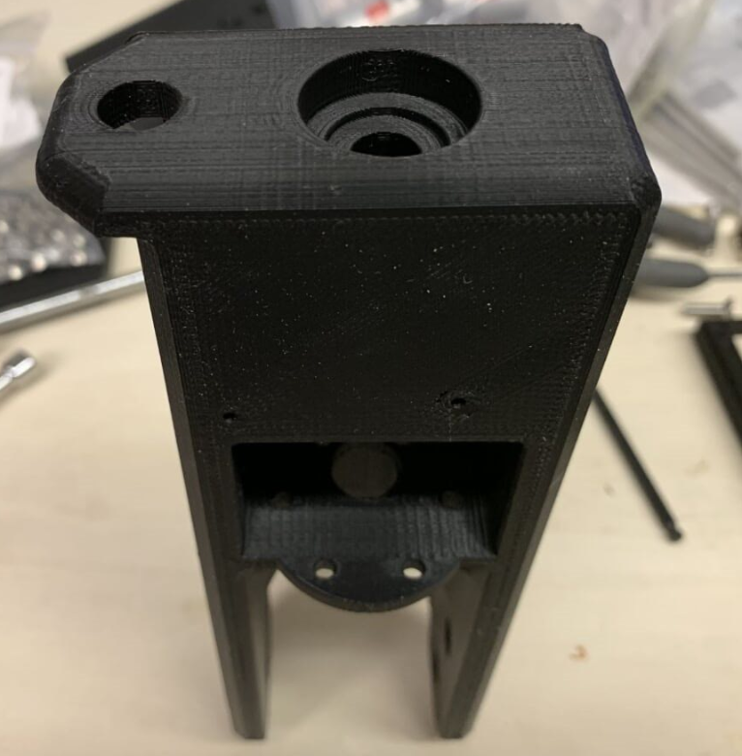

Insert 2 x 8mm Bearings

|  |  |
| --- | --- |
| 1 through the top | And 1 through the underside opposite |

Use the 300rpm or higher motor and insert into lower chamber

Use 2-4 (depending how many you can fit an Allen wrench into…) 3m x 8mm button bolts.

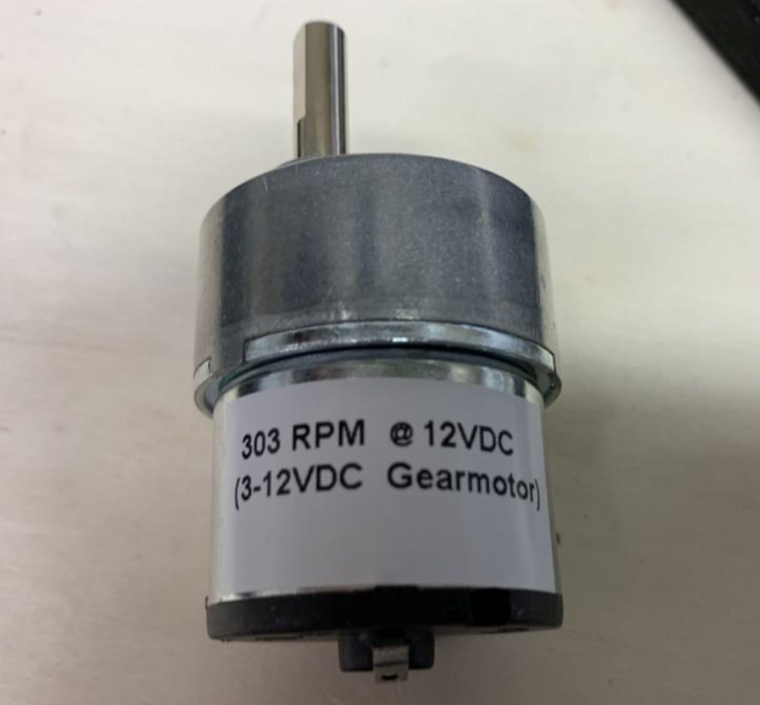

# Servo Mount Connections

## When installing the horns

You should put a 'horn' randomly, in any direction, on a servo then slowly rotate the servo using the horn to do it and note it's position clockwise and counter clockwise in each direction, then manually put the servo in the center of those 2 positions, remove horn from servo and reattach it so that the 'horn' is in line length ways with the servo body's long side.

# Flywheel MK3 Assembly

You can use the MK3 version of the flywheel which has the two outer rings only, however the assembly is the same between the previous versions and MK3.

Needed Parts:

# Changes and differences

1. There are several important pieces to consider:
2. The shadow environment requires 2 Mega Arduinos.

NOTE: I recommend that the main drive consist of the Mega while the shadow controller utilize the Mega ADK (which has built in USB connector).

Otherwise you will need to purchase approved USB Shield and approved BT Dongle.

1. The shadow can utilize the SFX sound system **through the remote rather than the main system**. This is so we can take advantage of direct communications from joystick to the sound trigger.
2. The SFX system is connected **over serial rather than direct button** connections.
3. MPU uses raw and filters to achieve better performance **without interrupts and thus requires no other Arduino mini.**
4. The Dome communications are also moved to the Shadow controller.
   1. SHADOW uses Serial2 to communicate to a feather wifi device.
5. Pin configuration is different with each system having a dedicated enable pin (future use).
6. The values being passed from Remote Controller to the main board also differ with additional items being passed:
   1. Direction
   2. Calibration
   3. Aux